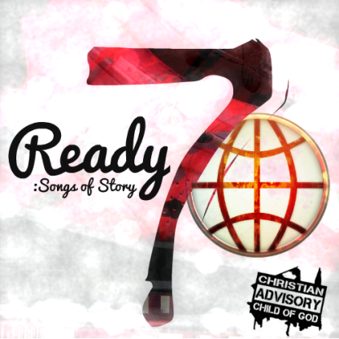
Intro: It’s only One that truly matters! Do you remember?

Chorus:
All my life I betrayed myself, double-played myself, couldn’t save myself
All my life I been on my grind, never waste no time, till I lost my mind
But Christ found Me and He saved my life
(yeah He saved my life, yeah He saved my life!)
Do you know Christ? He can save your life!
(yeah He saved my life, yeah He saved my life!)

Verse 1:
I’m optimistic, no rules no religion, only glorified trials on the road through redemption
My present, exemption, is never tasting death,
recognized I needed help, and found life in every step,
victory in every breath, I’m not just blowing smoke,
cracked a joke and broke the yoke and saw my burdens out to go
upped the ante for the shame, paid the debt in every way
showed the riches of His glory, then suggested that I stay
I saw my bank stop, my friends drop, and the whole world tripping
Then His spirit like a flood, in a rapid rush of Blood
And with my hands raised, my heart racing, my feet start praising
That’s when he saved my life, Praise God, You Saved My Life!

Verse 2:
It’s only One, so take the One way, I got a letter from the One,
He male models, rip the run way,
Hollywood, take five, that’s okay, but when you’re working the one, its only one take
Leave your celly, leave your briefcase,
And furthermore I need to tell you, there’s no lottery or sweepstakes
You’re not dealing with a cheapskate, unsearchable are His riches, I’m in Ephesians 3:8
I remember, don’t ask me, I remember, I remember, I remember, I remember
But wait, I forgot, wait a second, I think I recollected
Only way we’ll get to Heaven is through Christ, who saves our lives

