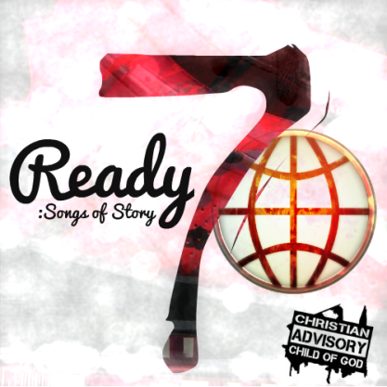
Intro:
{whistle} (another chance) I’m feeling good this evening, no doubt, let’s get this show on the road!
(Yessir!)

Chorus:
Lord, I Thank You, You Blessed Me, You Kept Me, Protected Me From My Own,
I Wake Up, and Praise You, Bow My Knees, Lift My Hands, Rejoice in My… (Chaaance!)
Today’s Another (Chaaance!), You Gave Another (Chaaance!), I Thank You For This (Chaaance!)

Verse 1:
I know that, you’re with me every moment I go through,
Doing the doings I Do when I’m, not, supposed to.
Never Forgot, How Quick, The debt was dropped; The Christ is risen, doors open, gate’s not locked.
In my case, it’s one of unforgettable Grace, who relates? To how He unveils, revealing His face, as a light
And surely one that’s just too bright to behold, as a Man
Sincerely, a chance, is something I know, is truly precious
The one who forgives is certainly gracious, and courageous.
To put up your heart to be exposed again? Betrayed again?
What’s a friend? Comprehend, the Love of he who came and gave His life for your!
Christ renewed! He’s the proof!

Verse 2:
This is the prequel to the sequel of a perfect world.
Where perfect people are individuals of every nation, every language, and every race
Children of faith, beneficiaries of Grace, where love is agape.
So in this prequel, I surrender, to the truth, no pretender,
He’s the root and the offspring of David, King of Kings, Lord of Lords
Acknowledged as the source of every chance, for every woman, every baby, every man.
Especially this man, from glory unto glory, story after story, I recount
That amounts to the person that I am today, unafraid, boldly state,
No mistakes, never Break, never Fold, Jesus Saves, Now You Know!

